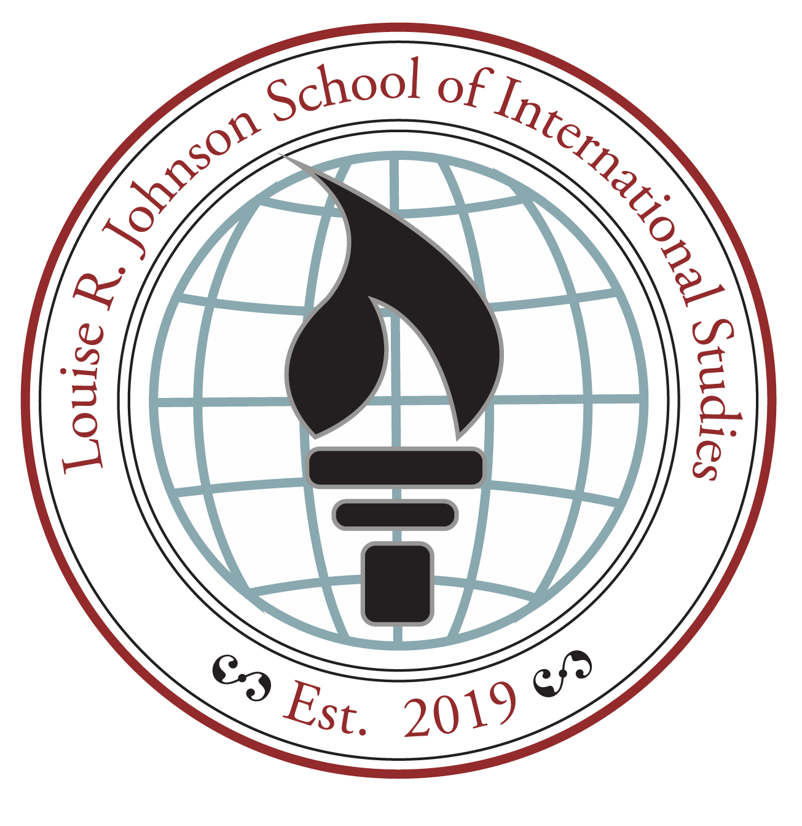
Johnson K-8
School of International Studies
SAC Meeting
September 19, 2024

6:00 P.M.

Convener/Facilitator:
Dr. Guy Grimes
Kim Dalglish

The mission of Louise R. Johnson K-8 School of International Studies is to inspire students to achieve academic excellence, embrace global diversity, and become lifelong learners.

GOALS: Strengthen the school’s educational beliefs and values, which reflect IB philosophy; ensure the implementation of the IB program with fidelity; conduct collaborative planning and reflection that supports the implementation of the IB program; develop written curriculum that reflects IB philosophy; cultivate teaching and learning that reflects IB philosophy; and create and implement assessment that reflects IB assessment philosophy.​

PROTOCOLS:
- Be on time and participate fully.

- Respect the opinions of others.

- Ask questions and offer opinions.

- Take care of yourself.

- No “side bar” conversations.

SAC Meeting 6:00 P.M.
Call to Order Noah Windspirit
Approval of May & August Minutes (Action Required)
SAC Budget Report

Principal’s Report: Dr. Guy Grimes
- IB Deep Dive Topic
- Security
- Clubs Update
- Parental Involvement Opportunities
- Mad Science (Action Required)
- No October Meeting, add November 14th (2nd Thursday)

Meeting Adjournment Noah Windspirit

UPCOMING EVENTS
September 2024
- 20/27 Fri Uniform Buyout / Wear Your Own Shirt Day

October 2024
- 1 Tues Fall Pictures
- 3-4 Th-Fri Rosh Hashanah
- 4/11 Fri Uniform Buyout / Wear Your Own Shirt Day
- 11 Fri End of Quarter 1
- 12 Sat Yom Kippur
- 14 Fri RECORD/PL DAY (No school for students)
- 17 Thurs Report Cards
- 17 Thurs NO SAC MEETING THIS MONTH
- 18 Fri Pep Rally (modified schedule)
- 21 Mon Fire Drill, 1:35P
- 23-31 1 wk Red Ribbon Week
- 25 Fri Uniform Buyout / Wear Your Own Shirt Day
- 30 Wed PYP Quarterly Awards (K-5), 9A

November 2024
- 1 Fri Uniform Buyout / Wear Your Own Shirt Day
- 3 Sun Daylight Saving Time Ends
- 5 Tues Safety Matters, 6th Gr, 1st per, Cafeteria
- 6 Wed Professional Learning Early Release, 1:50P
- 7 Thurs Picture Retakes
- 8 Fri Uniform Buyout / Wear Your Own Shirt Day
- 11 Mon Veteran’s Day, NO SCHOOL
- 12 Tues Safety Matters, 7th Gr, 1st per, Cafeteria
- 14 Thurs Level Up and IB Day
- 14 Thurs PTO (5:30P) / SAC Meeting, 6P (2nd Thurs)
- 15 Fri Uniform Buyout / Wear Your Own Shirt Day
- 15 Fri Progress Reports
- 15 Fri International Festival, 5-8P

Next Meeting:
November 14, 2024
(2nd Thursday)

