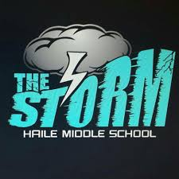

Haile Middle School Agriculture Safety Agreement

* Follow all instructions given by the teacher
* Know how to use all first aid and safety equipment
* Notify the teacher of any and all accidents
* Work appropriately with animals
* Protect my eyes, face, hands, and body when working in the Land Lab
* Clean, dry and return all lab equipment properly
* Conduct myself in a responsible manner at all times
* If at any time, I can not follow these guidelines and depending on the severity of the safety infraction, either to ones self or others, I may be removed from the agriscience program.

I, (Print Name) _______________________, have been instructed in the Land Lab Safety and emergency techniques needed for my Agriculture class. I understand and agree to follow the lab safety regulations set forth above. I am aware that my safety and the safety of my classmates depends on my behavior in the Classroom and Land Lab. With this in mind, I will closely follow the oral and written instructions provided by my teacher and/or the school administration.

Date: ______________ Student Signature: _______________________

Please list any allergies: ________________________________________

____________________________________________________________

Parent Signature: __________________________

Parent Phone Number: ______________________

Date: __________________